PJ Paiboon Julasaksrisakul King Pac Industrial in ChemOrbis Member Views
ChemOrbis 2nd Annual Meeting on April 4, 2011 in Singapore with more than 450 professionals from 260 companies and 19 countries getting together to discuss the issues vital to the plastics industry and to build new relationships through face to face meetings with potential business partners.
View Online Here
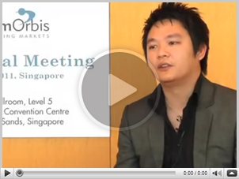

Link VDO
https://www.youtube.com/watch?v=CP-5bBx82cM&feature=youtu.be

